*instruction on running this script.

*note that this script is composed of 2 files:
- script_runner_ER40_redcap_extractor.bat
- script_source_ER40_redcap_extractor.py

side note : the reason why there are 2 files is that to we can bypass windows security that blocks random python scripts from running (bypass only for our script).

So where do you put these files? :
you would put these files in the same area as the run_er40.bat script, right next to/ in the same area as the psychopy project folder (ER-40) :

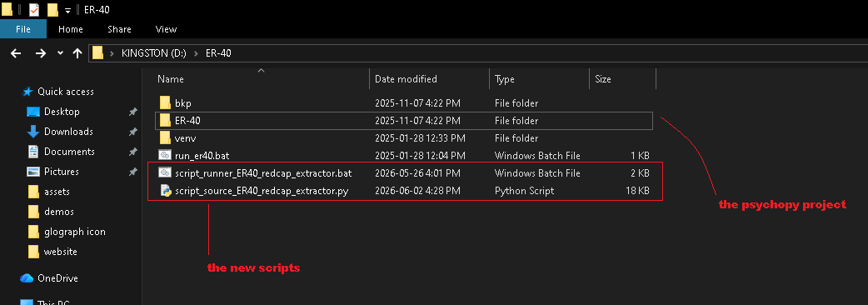

*these 2 files must always be together in the same folder.
to run the script just double click the script_runner_ER40_extractor.bat file

---------------------------------------------------------------------------------------------------------------------------

*in case you system says somthing like :
« file is blocked since unknown files comming from the internet
could be dangerous »

- right click, with mouse or touchpad, on the file called script_runner_ER40_redcap_extractor.bat

- then click properties :

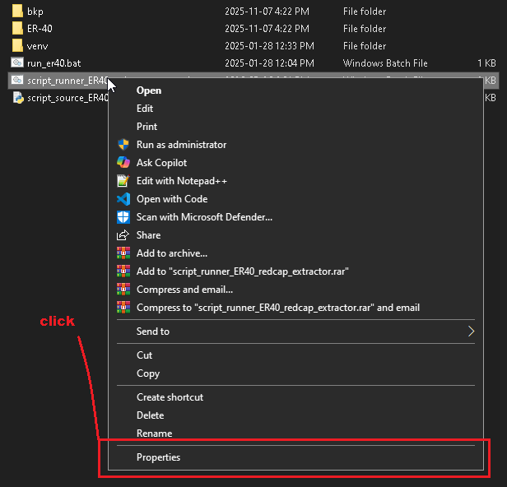
- and at the bottom of the pop up check the unblock box and then click ok :
I don’t have an image for this one since the error mostly happens on windows 11 (I have widows 10)

now you should be able to run the script from the script_runner_ER40_extractor.bat file

